Application and Registration Form

Open Symposium “Challenges to achieve Low Carbon Society
- 1st anniversary of Kyoto Protocol -”
MoEJ/British Embassy/NIES

To: Yuki Mitsuhashi, NIES (三津橋)

E-mail: mitsuhashi.yuki@nies.go.jp
（FAX：029-850-2572）

Please fill out the following items and email (or fax) it by Feb 9 (Thu.). We will email (or fax) back this application form to you with the registration number. Please bring it with you on Feb 16.

Name
Position
Affiliation
Address
Phone No
FAX No
E-Mail Address
How to know this symposium?
Can we provide related information to you? | Yes or No
Registration No.
（for office use）
Contact: Mitsuhashi/ Fujino Tel:029(850)2504

Private policy: We will not provide personal information
to any third party without the prior consent of a customer.
__________________________________________________________________________
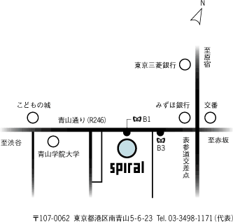
Information:
Time: Feb. 16 (Thu.), 2006, 18:00-20:30 (Open 17:30)
Venue: Aoyama “Spiral” Hall
5-6-23 Minami-Aoyama, Minato-ku, Tokyo
1min. walk from exit B1 or B3 at Omote-sando subway station http://www.spiral.co.jp/

